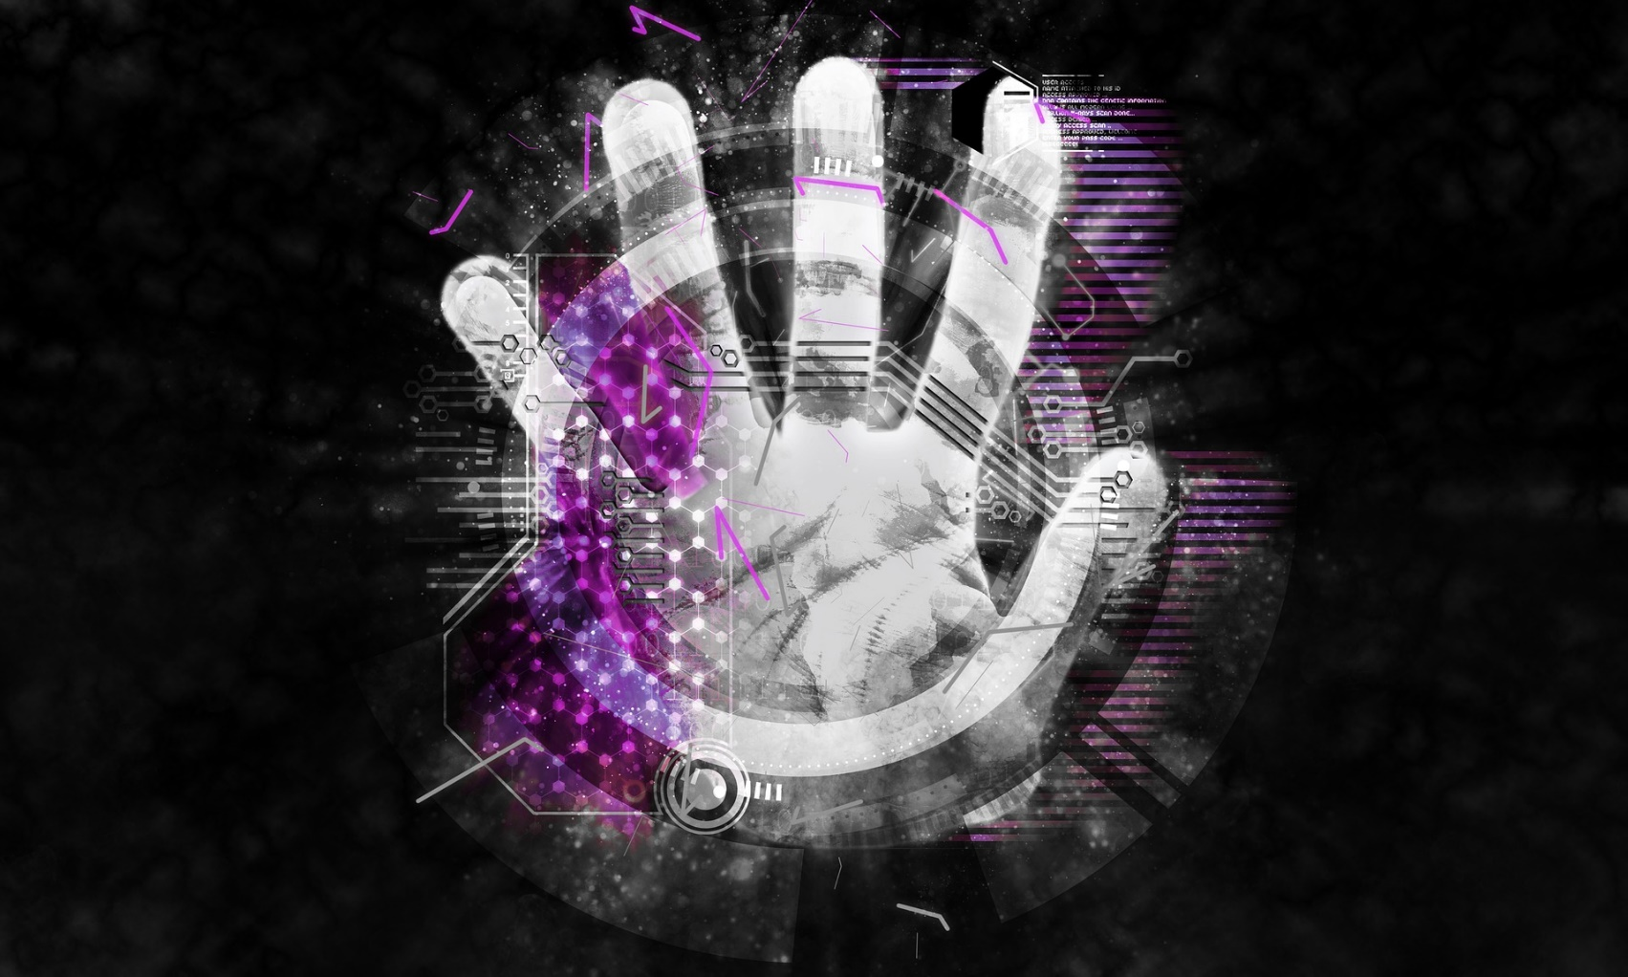

Neehack

Neehack

Technology

Website: https://www.neehack.com/

Phone: +1 (437) 237 1562

Email: support@neehack.com

Email: abdul.wajed@neehack.com

We are experts in building and securing using artificial intelligence. An active community in cyber security. Our free tools are used world-wide for security assessments. We offer Software Developing, Communication Solutions and Cyber Security Services such as Penetration Testing, Incident handling, Audit and more from small to large businesses.

Our free security services include a crack engine that have the potential to be the fastest crack engine in the world, a cyber threat map that shows live cyber-attacks world-wide, daily security related news, security assessment tools, exploits and more.

About Us

Our Vision

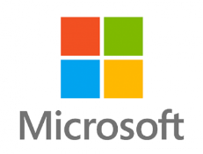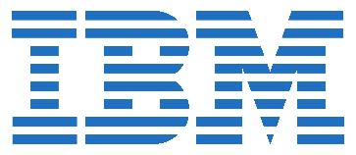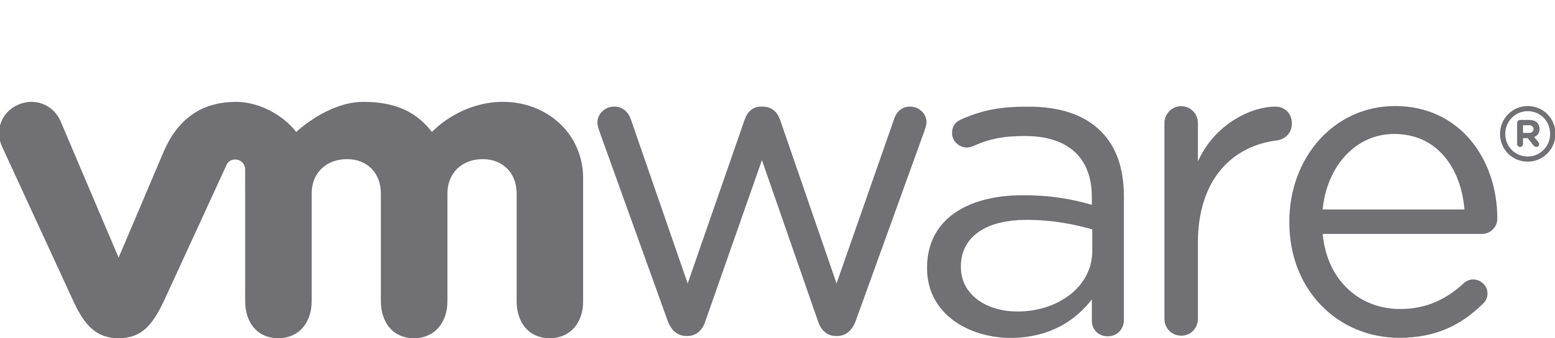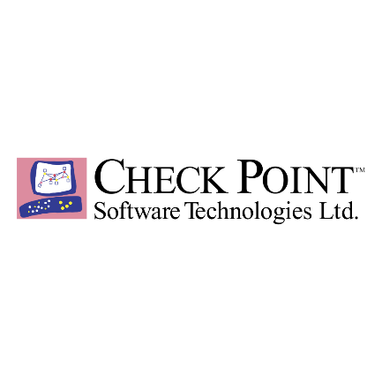

At Neehack, we think outside the box. We develop new methods to unveil the darkest parts of your network. Tell you things, even you didn’t know about your organization. We build smart technologies using artificial intelligence (AI).

Hands-On Penetration Testing

Our Partners

Our main focus is to build intelligent technology and secure intelligently.

Web and Network Penetration Testing SAST/DAST

* Web-Based and Network-Based are the most common types of penetration testing.
* Network penetration testing includes evasion of IPS/IDS, Proxy. Identifying miss-configuration in network-based firewalls or network services such as SSH, FTP, SMTP, RDP and more.
* Web application penetration is a technique for detecting security flaws in web-based applications.

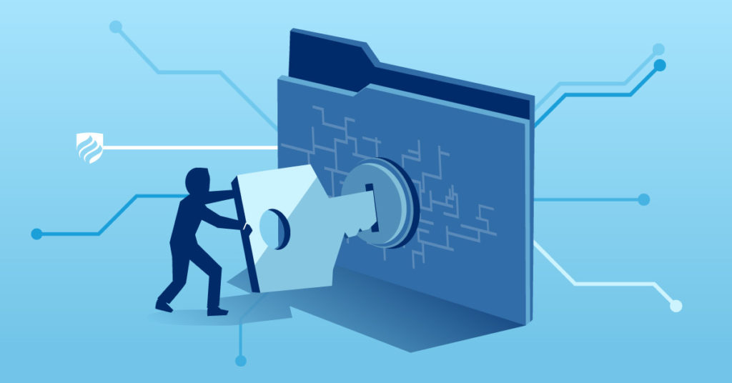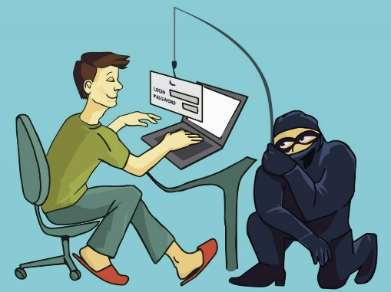

Physical penetration testing is a form of threat simulation in which a pen tester tries to breach physical barriers to gain access to a company’s infrastructure, building, systems or employees.

Physical Penetration Testing

Social Engineering

A threat actor uses social engineering to convince or manipulate internal employees into providing classified data such as login credentials.

* On 2020 Neehack identified a new method to develop malware (for ethical and research purposes only) that could bypass almost every end-point security tool including Kaspersky, McAfee, Avast, SentinelOne and more. Learn more about viper in here: <https://www.neehack.com/article?post=1EWBVLACJ5>
* On 2020 Neehack Identified a method and provided a PoC on how an attacker could bypass Network Address Translation (NAT) to attack a private network. Learn more about it here: <https://wajid-nawazish.medium.com/is-it-possible-to-attack-a-private-network-f9fa8ef5e997>
* On 2020 Neehack developed a tool to proof how easy it is for an attacker to perform TCP Data Injection without any user manual work. Learn more about tcpF here: <https://github.com/MrMindKeeper/tcpf/blob/master/tcpf.c>
* Are you wondering if your security controls are configured well enough to protect you from becoming the next victim? Let us tell you, your security gaps that might lead to a security compromise by performing a security audit of your organization.

Security Audits

Top 3 Neehack Zero-Day Findings in 2020

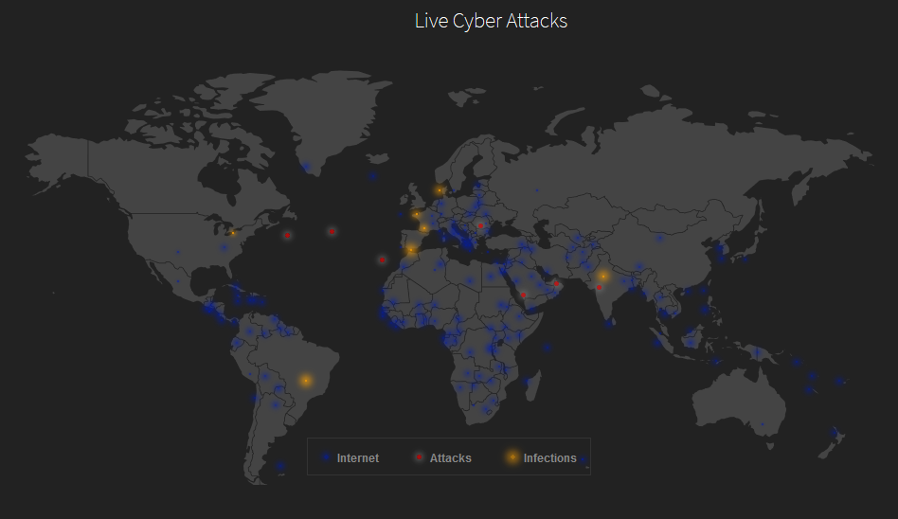

* Neehack threat map is a free service that shows live cyber-attack and infections world-wide. For visual preview visit: <https://www.neehack.com/map>
* Neehack Crack Engine is an agent-based crack engine that can potentially be the fastest crack engine in the world.
* How does it work?
  + There are two parts in this crack engine system. One the core Engine which handles the hashes given to crack and manages the engine agents. The core engine is not responsible or do not recover the hash by itself.
  + The Agents are responsible for recovering the hash. You can deploy as many agents in as many assets as you want.
  + We have deployed over a dozen of Neehack Agents world-wide which are continuously 24/7 working to recover forgotten passwords. Once a hash is given to the core engine for recovery. The core engine requests its agents to start working on the given hash and respond with the recovered password.

Neehack Threat Map

Neehack Crack Engine

Phone: +1 (437) 237 1562

Email: support@neehack.com

Live Chat Support: https://www.neehack.com/

Email: abdul.wajed@neehack.com

Contact Us or Get a Quote